Nepal College of Information Technology
Assessment
Fall 2011
Program : BE ELX/CE Time : 3 hrs
Semester : Fall FM : 100
Subject : Numerical Methods

- Candidates are requested to give their answer as far as practicable in their own words.
- The figure in the margin indicates the full marks
- Attempt ALL question
1. a) Solve e^{x} Sin x – x² = 0 by N-R method correct to three decimal place. [7]
b) Solve 3x + sinx – e^{x} = 0 by secant method correct to four decimal place. [8]

2. a) The following are data from steam table:

Temp (t) | 140 | 150 | 160 | 170 | 180
Pressure | 3.685 | 4.854 | 6.302 | 8.076 | 10.225

Using Newton’s formula, find the pressure of the steam when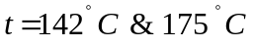. [8]
b) The temperature of a metal strip was measured at various time interval during heating and values are given in the table below:
Time, t (min) | 1 | 2 | 3 | 4
Temp, 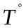(C) | 70 | 83 | 100 | 124

If the relationship between the temperature T and time t is of the form
T = b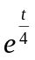 + a
Estimate the temperature at t = 3.5 min. [7]
3. a) Evaluate 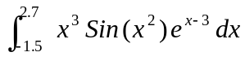
By Gaussian three terms formula [7]
b) Evaluate 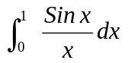 by [8]
i) Trapezoid Rule
ii) Simpson’s 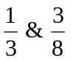Rule.
4. a) Solve
x+2y +z -w = -2
x+y+3z-2w =-6
2x+3y-z+2w=7
x + y +z +w =2
By Gauss elimination method. [7]
b) Solve
10x-2y-z-w = 3
-x-y+10z-2w = 27
-2x+10y-z-w = 15
-x-y-2z+10w =-9
By Gauss-seidal iteration method. [8]
5. a) Solve 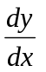= y+ sin x, y(0) = 1 for y(2)
By method of RK- 4th order. [8]
b) Solve 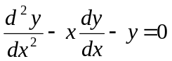, y(0) = 1, y′(0) = 0 to find y (0.2) & y′ (0.2) using RK-4th or 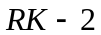 method. [7]
6. a) Find the largest eigen value & corresponding eigen vector of the matrix
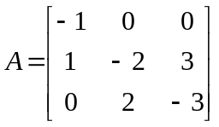 [8]
b) Find the missing value from the following table [7]
x | 1 | 2 | 3 | 4 | 5
y | 2 | 5 | 7 | - | 32

7. Write short notes on (Any two) 2*5
a) Convergence of Newton-Raphson method.
b) Fitting of curve by least square approximation method
c) Ill condition system.

